April 2022 Newsletter

Shining
Promise of warmth
Snow melted from our sight
The false spring howls in glee
Cold toes.
By Nevada Pakka

Remember to keep warm through this cold spring as the warmth still hasn’t come yet, and welcome in national poetry month as we hope for warmer weather for Easter.
-Nevada P.

Easter Gift bags!

The Sik-E-Dakh Band Office will be receiving and handing out Easter gift bags for each household on April 13th and 14th straight from the Easter Bunny itself! Be sure to hop by to pick it up!

Education News

Hello Glen Vowell Community,
I am happy to let you know that I am now the Community Education Coordinator here in Sik-E-Dakh. It’s great to be back in the Village! In this role I am here to encourage each of you, young and old, in your education/life goals. As I grow into this role, I hope to find many ways to be supportive. Looking forward to seeing you!
Johannah Sessford

Parents and Community Members:
You are invited to join me at the high school (HSS) for a Community Think Tank on Thursday April 14. It is an all- day event with morning snacks and lunch provided. Please call me at the Band Office for more information and details. Thanks!
Johannah

Upgrading and studies funding:
Living allowances and other supportive funding are available for those wishing to further their education locally (GWES, CMC, Farm School, Contact North and Incidental programs) or further away (Prince George, Terrace, Vancouver, etc.) The deadline for funding applications is May 31st 2022, However, I will be away the last two weeks of May, so please come and see me in April if you are thinking of extending your education this summer, January, or sooner. Thanks!

Johannah.

High school Students are encouraged to bring in their Report card in to the Sik-E-Dakh band office to receive a financial reward for their marks in class work.

Social Development Corner

Here is your monthly reminder to come to the Sik-E-Dakh band office to fill out your renewal slip for Social Assistance before the 20th of each month in order to receive your cheques at the start of the next month. Please also remember to bring in your BC Hydro bill if you would like to have help with it.

If you are in need of applying for Social Assistance you may come up the Sik-E-Dakh band office to pick up an application package to fill out and send in to Carlene Wright the Social Development worker.

Employment Opportunities:

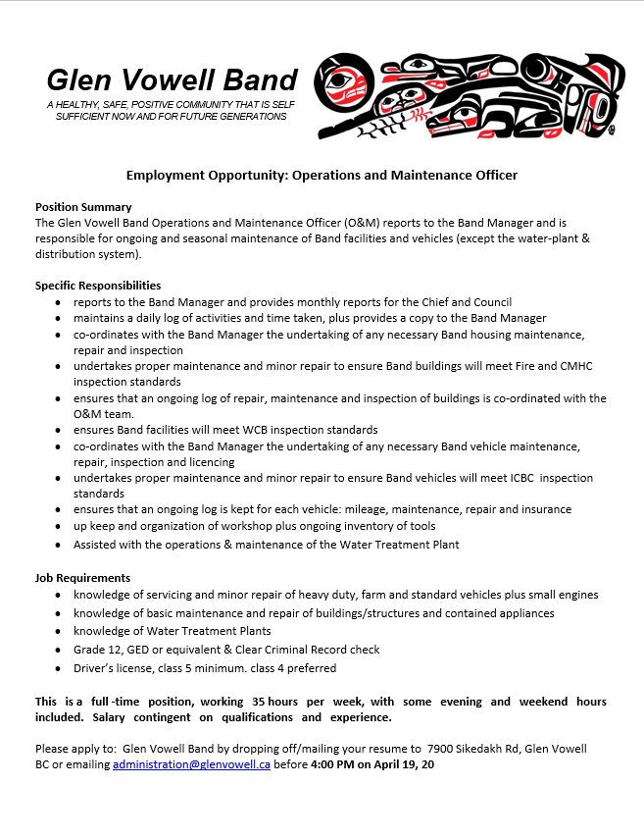

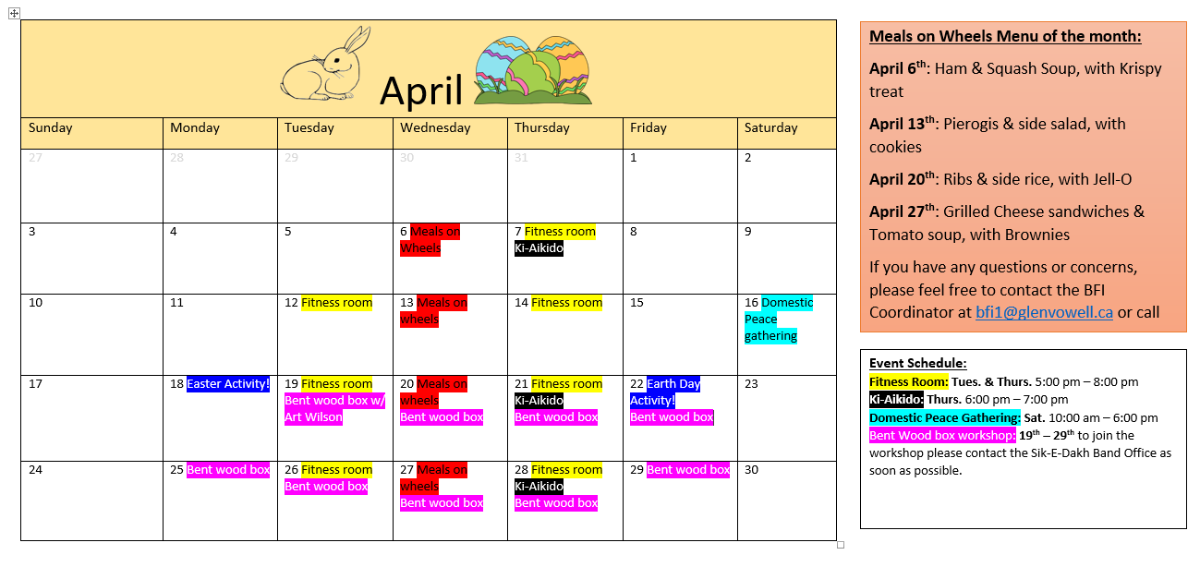

Hall Events
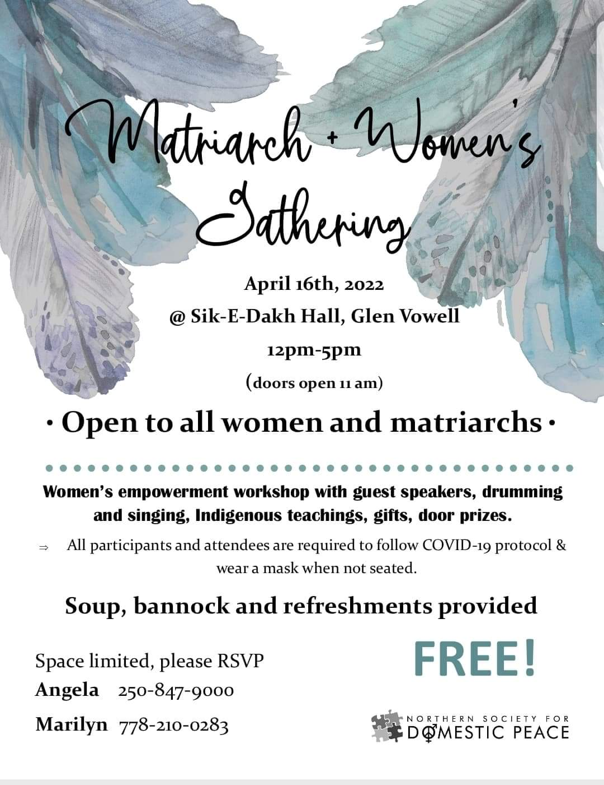

GREATEST EASTER EGG HUNT!!

The Easter bunny will be hoping around the community on Monday the 18th!
Come on down to the soccer field at 1pm and see if you can find any hidden eggs or treats!

