May 2022 Newsletter

LARRY GODFREY HNIDAN
ALL CLANS POLE

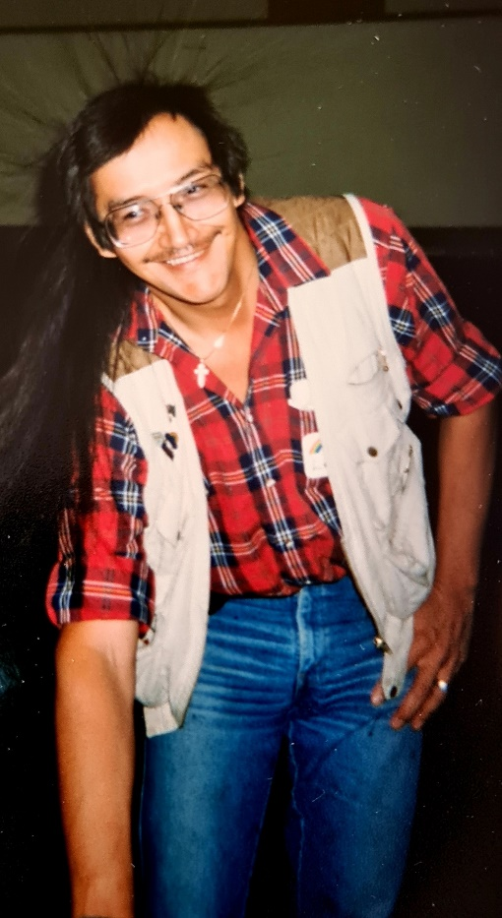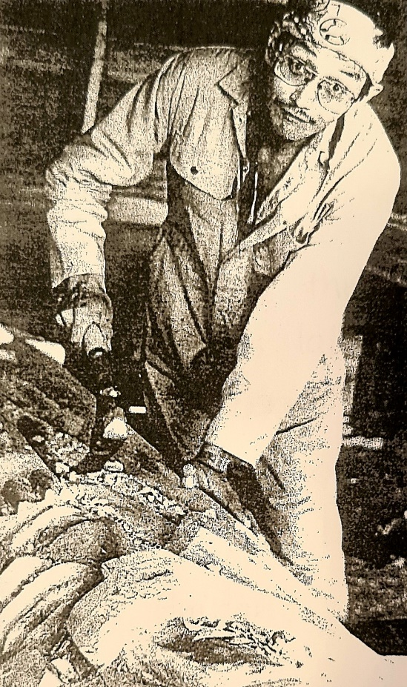

In 1992 Larry Hnidan started the pole and created the beautiful designs of the frog at the base, a human woman in the center & the owl at the top.
The pole was completed in honour of Larry in 2007 by Dan Yunkws with the guidance from the late Earl Muldon.
We are asking the assistance of the community of the Sik-E-Dakh with regard to where they would prefer to situate the “All Clans Pole”.

Please drop off your suggestions at the Sik-E-Dakh Band Office or Email it to reception@glenvowell.ca .

Thank you very much.

There is a new electric fence that is installed around the Chicken paddock behind the Sik-E-Dakh band office in order to prevent wild animals from attacking them.
PLEASE DO NOT TOUCH THE FENCE FOR YOUR OWN SAFETY.

VET TO PET
Vet to Pet may be coming to Sik-E-Dakh to offer spaying and neutering to your pets at no cost to the owners. We encourage you to take this opportunity as it has proven to lower aggression in your pet there by protect not only them but community members alike.
Please contact reception at the band office to put your name on the list for interest.

SOCIAL DEVELOPMENT CORNER

A reminder to those who are on S.A. to fill out your forms before the 20th of each month in order to be paid at the start of the next month.

Also if you are wanting the band to help you with your BC Hydro, please remember to bring in your Hydro bill.

EDUCATION NOTIFICATIONS

There will be a lunch hosted by the Education Coordinator for the Sik-E-Dakh high school students on May 12th, 2022. Feel free to drop by the room to chat and get to know the education coordinator.

Post-Secondary applications are available here at the Sik-E-Dakh band office if you would like to apply for funding for a college or university program. You can also contact the education coordinator thought email at education@glenvowell.ca to get more information and receive an electronic copy or the application.

BRIGHTER FUTURES INITIATIVE

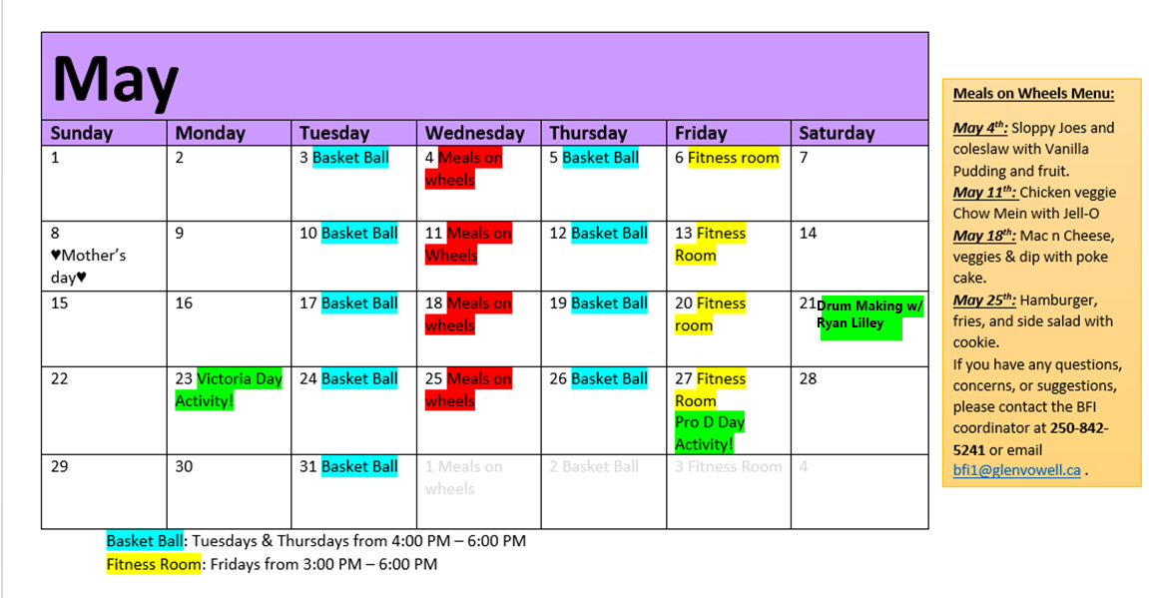

BFI UPDATES

