JUNE 2022 NEWSLETTER

Monday, June 27, 2022
Chief and Council Quarterly Community Meeting
Sik-E-Dakh Hall
7 PM- 9 PM

Agenda
- New Builds Lots 156, 157, 107
- Community Beautification
- Fire Department

All Community Members are welcome to attend

Join via Zoom Meeting
https://us02web.zoom.us/j/7379979017

Meeting ID: 737 997 9017

Glen Vowell Band Housing Updates:
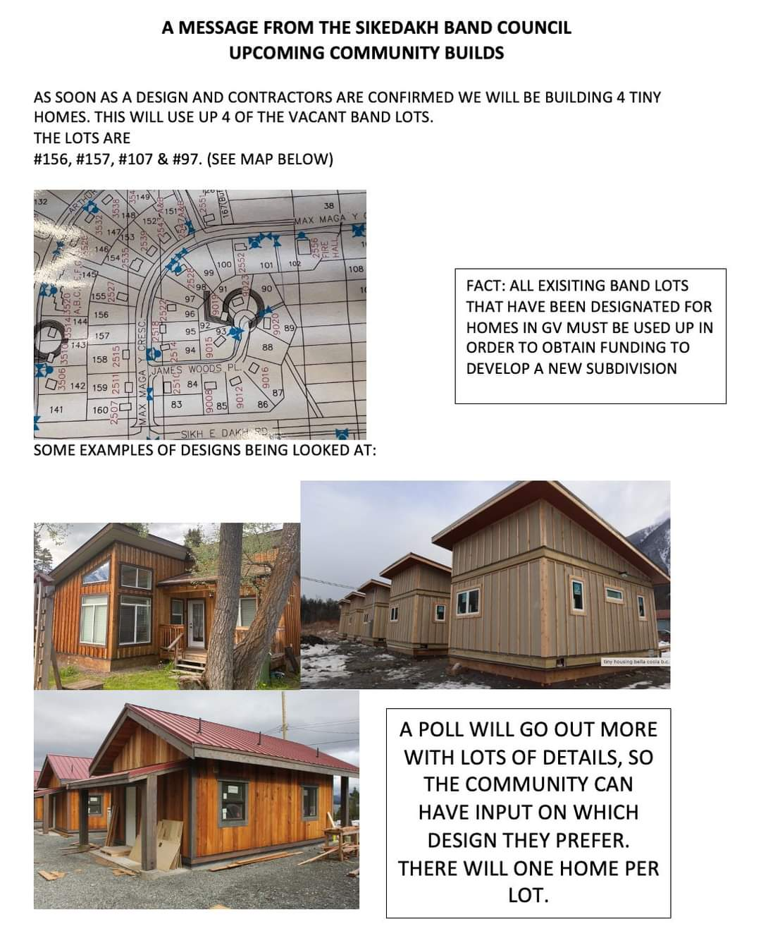
Please be Advised:
Trees will be cut down on Band Lots 156 and 157 (between Cliff Weget's home and Kelly Wale's home) to prepare the lots for two tiny homes. Please pay attention to the safety people who are monitoring the site.
.

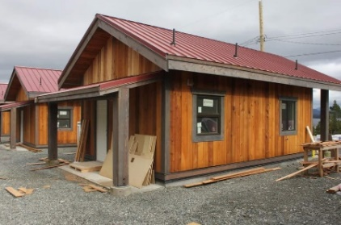

SOCIAL DEVELOPMENT CORNER
A reminder to those who are on S.A. to fill out your forms before the 20th of each month in order to be paid at the start of the next month.
Also if you are requiring the assistance of the band with your BC Hydro, Please remember to bring in your Hydro bill.

Summer Student Employment

Starts on July 4th at 9:00 AM- 3 PM until August 5
Many resumes have been received and there will be work for everyone. Please show up at 9:00 AM and you will receive your job assignment. Please be dressed to work in the garden unless you have received a call letting you know otherwise (ie. Closed toed shoes, long pants and long sleeves, water bottle, sunscreen). There will be a lunch break from 12:00-1:00 PM. Thanks for all those who have applied.

EDUCATION CORNER
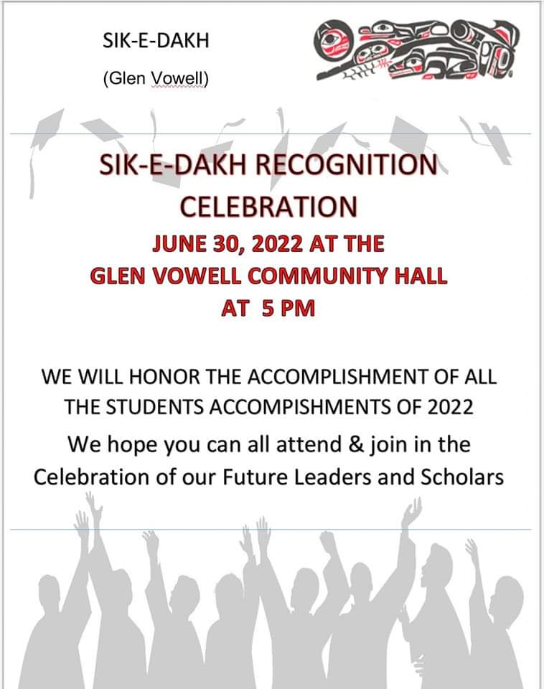

If you require further information please contact Education Coordinator Johanna Sessford at (250)842-5241

Post Secondary applications are available here at the Sik-E-Dakh band office if you would like to apply for funding for a college or university program. You can also contact the education coordinator thought email at education@glenvowell.ca to get more information and receive an electronic copy or the application.
DEADLINE TO APPLY MAY 31, 2022
( Late Applications will be accepted and put on a waitlist)

GLEN VOWELL LEARNING CENTER
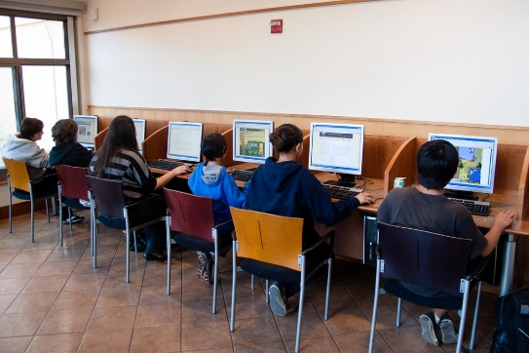
Please Come in to the Sik-E-Dakh Learning Center situated in the GV Board Room Update Resumes, Job Search, search for online courses. Please Contact the Band Office for scheduled times to access Computers.

SIK–E-DAKH HALL UPDATE 2022
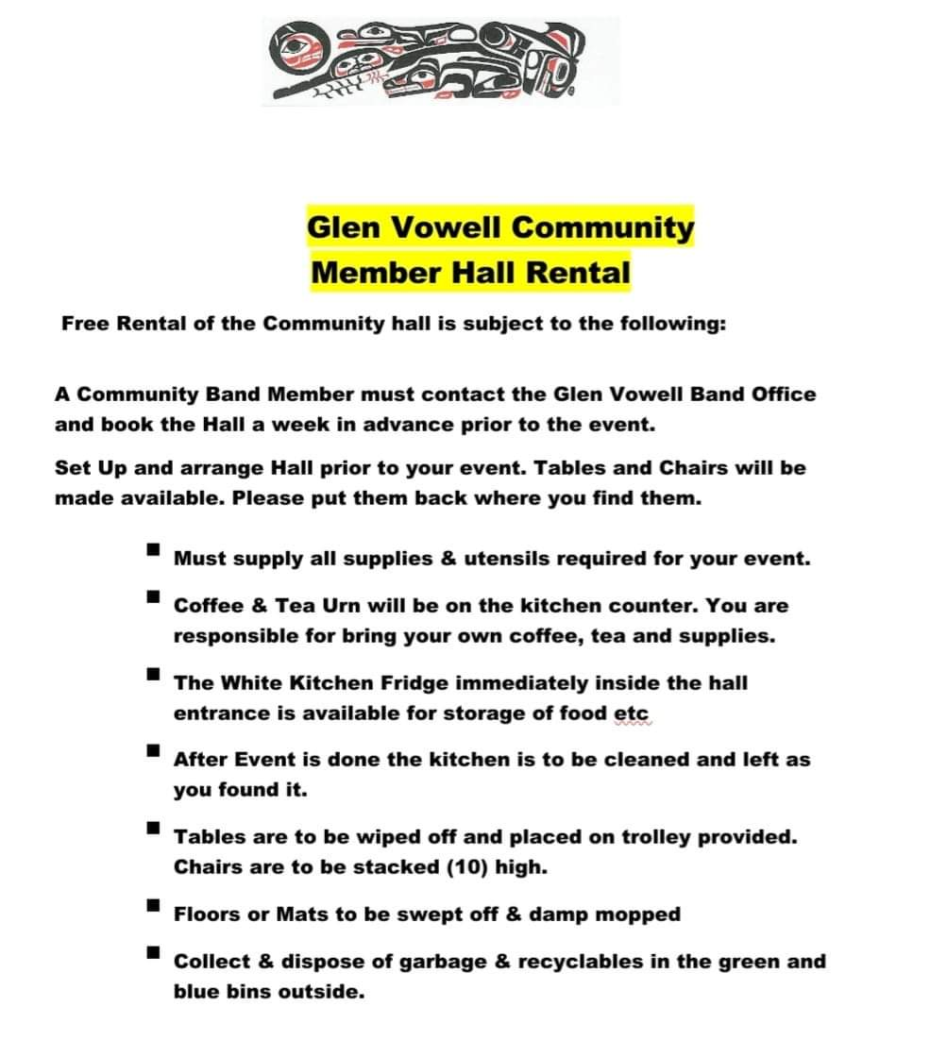
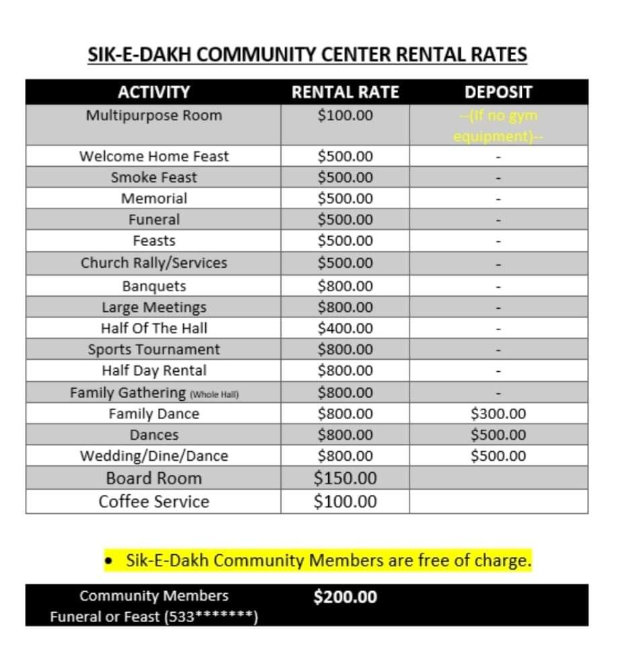
IF YOU WOULD LIKE TO BOOK AN EVENT PLEASE CALL AND BOOK IN WELL IN ADVANCE

