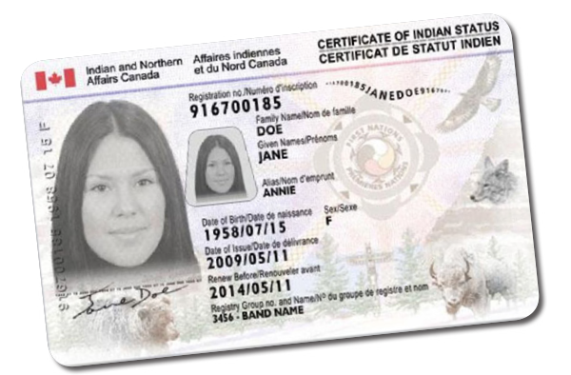

ALL CUSTOMERS

PLEASE PRESENT A VALID & UPDATED STATUS CARD TO STAFF OVERSEEING SALES PRIOR TO PURCHASING CIGARETTES☺